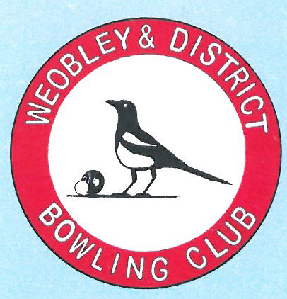
Data Protection Policy

25th May 2018

____________________________________________________

As a member of Weobley & District Bowling Club you have consented to be contacted by the officers and other members of the club. Please see the information below that explains what data we hold and why we need to keep it on file.

What information do we hold?
We require your name, address and contact details such as phone numbers and email. We also record your membership status, and any receipts or payments made by or to individuals in the course of the club’s operation.

Where is it stored and why is it used?
We hold the aforementioned information in our secure database, and as appropriate in our accounting files, and it is used to communicate with members, track membership status, and maintain our accounts ledger. Names and phone numbers are also listed in the clubhouse to allow members to arrange fixtures, teams, etc. We will not use your data for marketing purposes.

Who is the information used by?
All membership data held by Weobley & District Bowling Club is processed by the officers of the club where it is necessary for them to undertake their duties. No third party will have access to your data unless it is required for the operation of the club (for example, the annual external audit, and affiliation with Bowls Herefordshire and Bowls England), or if there is legal obligation to provide it.

Withdrawal of consent
Under GDPR regulations all members have the right to enquire about and remove any personal information held by Weobley & District Bowling Club.

If you have any questions regarding this policy, please address them to an officer of the club.

